Assignment #7 Explore Tableau by Joshua Troup

Analytical Task: Find the sub-category of products across all segments whose sales exceed $100,000.

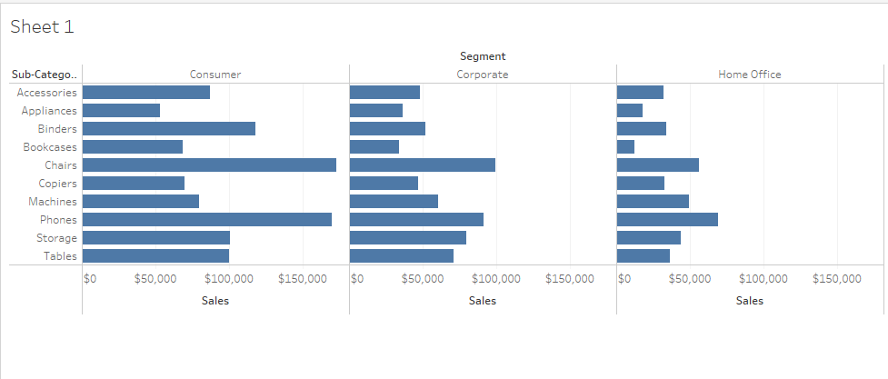

Using the same data source, Sample-superstore, find the sub-category of products representing the top 10 Sales. Which are the Top 2 from your analysis?

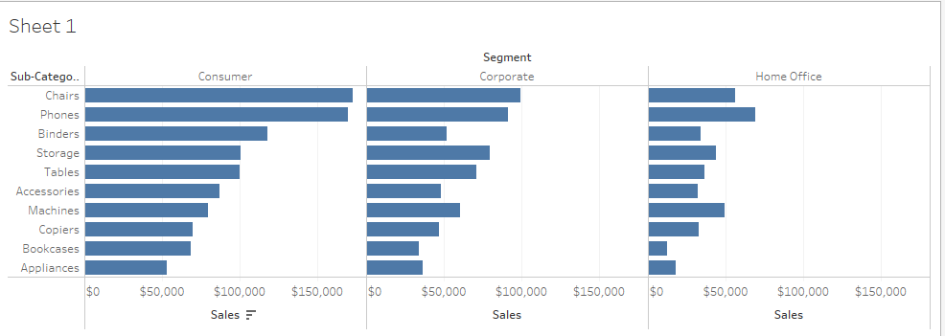

**The top 2 are Chairs and Phones with values of:**

**Consumer Corporate Home Office**

**$172,863 $99,141 $56,445**

**$169,933 $91,153 $68,921**

Can you align your measure w.r.t the median “Household Income” at a County level?

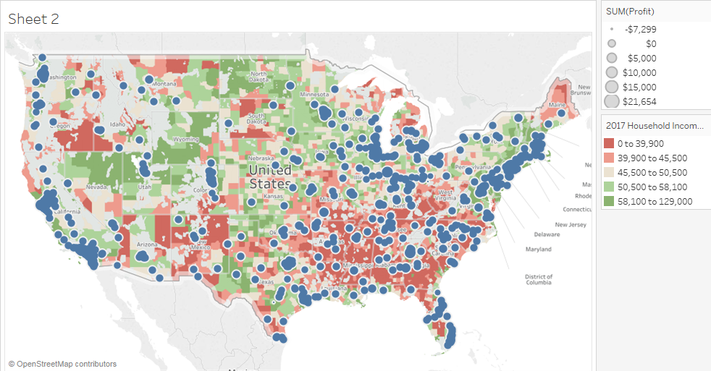

**Yes the geographical display shows the profit according to size of circle. The household income is displayed by color with 0-$39,900 red and $58,100-129,000 green. Placing the mouse over the circle gives the exact profit value in that particular county (zip code).**

Create a filled (choropleth) map by choosing Profit from measures and State from dimensions. Close the Show Me bar so that the Profit color code can be easily interpreted.

Which State has the maximum sales or Profit?

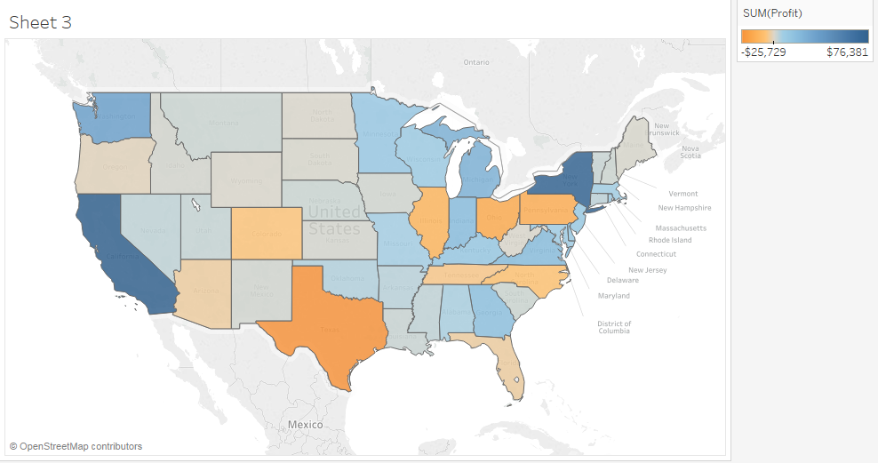

**California has the highest profit of $76,381.**

Can you easily tell the difference between any 2 top states by sales or profit?

**Yes if you hover the mouse over the dark blue states to discover the top profitable states. This data set shows to only have two dark blue states which shows California and New York showing the highest in profits.**

• Which one has more sales or profit?

**California has more profit.**

**California: $76,381**

**New York: 74,039**

• Which chart aids a decision maker better from the visual?

**Fill map is much easier for a decision maker to see what region or particular state is profiting greatly and which ones are not so strong. Symbol map is ideal if the decision maker wants to dig further into the data to show what counties in the state are performing.**

Try to create a Symbol Map in one worksheet and Bar chart in another worksheet.

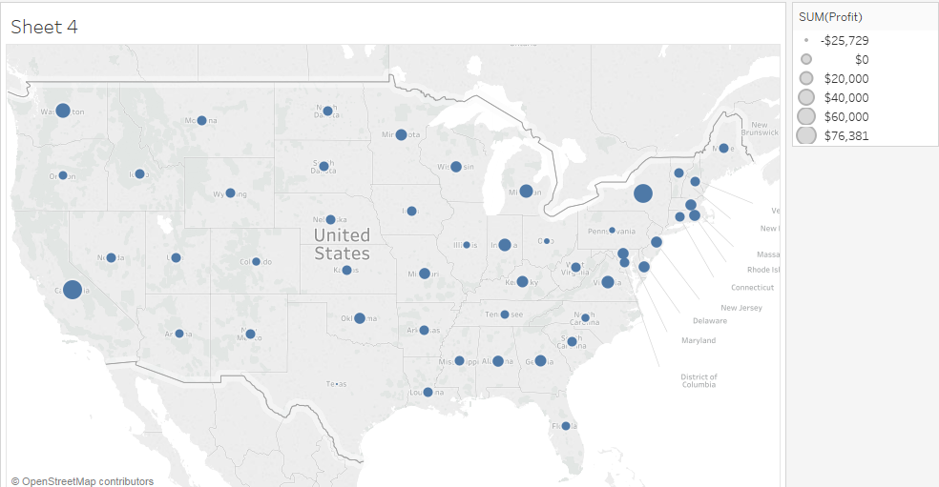

SYMBOL MAP

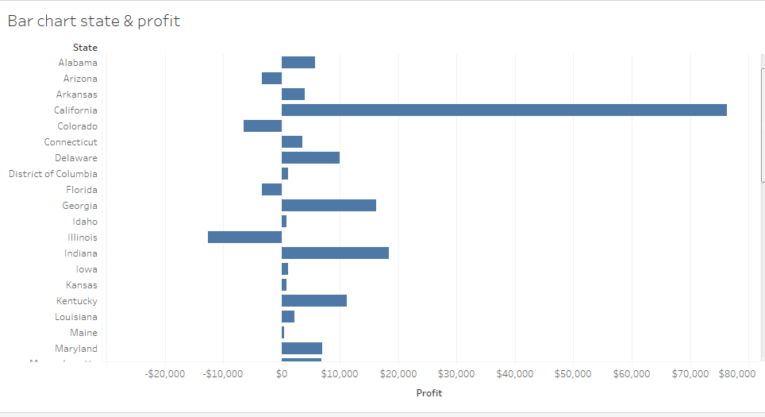

Can you easily tell the difference between any 2 top states by sales or profit?

**Symbol map is more difficult to determine the top 2 performing states compared to the bar chart which is clear and distinct. The bar chart also shows the negative profit by state with ease.**

• Which one has more sales or profit?

**California has more profit.**

**California: $76,381**

**New York: 74,039**

• Which chart aids a decision maker better from the visual?

**Bar chart would aid a decision maker more effectively and accurately as a whole. If a decision maker was only interested in a particular region then a symbol map would be beneficial.**